Campus-Aware Intelligent Lost and Found Management System Using NLP
A CAPSTONE PROJECT REPORT
Submitted in the partial fulfillment for the award of the degree of
DSA0308- Natural Language Processing
to the award of the degree of
BACHELOR OF TECHNOLOGY
IN
CSE-ARTIFICIAL INTELLIGENCE
Submitted by
A. Syed Thoufiq (192424211)
S. Mohammad Abrar (192472185)
B. Praneeth (192472222)
K. Subrahmanya Venkata Sai Manikanta (192472220)

Under the Supervision of
Dr. T. Kumaragurubaran

SIMATS ENGINEERING
Saveetha Institute of Medical and Technical Sciences
Chennai-602105
August-2026



SIMATS ENGINEERING

Saveetha Institute of Medical and Technical Sciences

Chennai-602105

DECLARATION

We, A. Syed Thoufiq (192424211), S. Mohammad Abrar (192472185), B. Praneeth (192472222), K. Subrahmanya Venkata Sai Manikanta (192472220) of the Department of Computer Science Engineering, Saveetha Institute of Medical and Technical Sciences, Saveetha University, Chennai, hereby declare that the Capstone Project Work entitled “Campus-Aware Intelligent Lost and Found Management System using NLP” is the result of our own bonafide efforts. To the best of our knowledge, the work presented herein is original, accurate, and has been carried out in accordance with principles of engineering ethics.

Place: Chennai
Date: 0/08/26

Signature of the Students with Names

A. Syed Thoufiq (192424211)
S. Mohammad Abrar (192472185)
B. Praneeth (192472222)
K. Subrahmanya Venkata Sai Manikanta (192472220)



SIMATS ENGINEERING

Saveetha Institute of Medical and Technical Sciences

Chennai-602105

BONAFIDE CERTIFICATE

This is to certify that the Capstone Project entitled “Campus-Aware Intelligent Lost and Found Management System using NLP” has been carried out by A. Syed Thoufiq (192424211), S. Mohammad Abrar (192472185), B. Praneeth (192472222), K. Subrahmanya Venkata Sai Manikanta (192472220) under the supervision of Dr. T. Kumaragurubaran is submitted in partial fulfillment of the requirements for the current semester of the B. Tech CSE-Artificial Intelligence program at Saveetha Institute of Medical and Technical Sciences, Chennai.
SIGNATURE | SIGNATURE
Dr. Sri Ramya | Dr. T Kumaragurubaran
Program Director | Professor
Department of CSE | Department of CSE
Saveetha School of Engineering | Saveetha School of Engineering
SIMATS | SIMATS

Submitted for the Capstone Project work Viva-Voce held on ___________________.

INTERNAL EXAMINER EXTERNAL EXAMINER

ACKNOWLEDGEMENT

We would like to express our heartfelt gratitude to all those who supported and guided us throughout the successful completion of our Capstone Project. We are deeply thankful to our respected Founder and Chancellor, Dr. N.M. Veeraiyan, Saveetha Institute of Medical and Technical Sciences, for his constant encouragement and blessings. We also express our sincere thanks to our Pro-Chancellor, Dr. Deepak Nallaswamy Veeraiyan, and our Vice-Chancellor, Dr. S. Suresh Kumar, for their visionary leadership and moral support during the course of this project.
We are truly grateful to our Director, Dr. Ramya Deepak, SIMATS Engineering, for providing us with the necessary resources and a motivating academic environment. Our special thanks to our Principal, Dr. B. Ramesh, for granting us access to the institute’s facilities and encouraging us throughout the process. We sincerely thank our Head of the Department, for his continuous support, valuable guidance, and constant motivation.
We are especially indebted to our guide, Dr. T. Kumaragurubaran for their creative suggestions, consistent feedback, and unwavering support during each stage of the project. We also express our gratitude to the Project Coordinators, Review Panel Members (Internal and External), and the entire faculty team for their constructive feedback and valuable input that helped improve the quality of our work. Finally, we thank all faculty members, lab technicians, our parents, and friends for their continuous encouragement and support.
Signature with Student Name

A. Syed Thoufiq (192424211)
S. Mohammad Abrar (192472185)
B. Praneeth (192472222)
K. Subrahmanya Venkata Sai Manikanta (192472220)

TABLE OF CONTENTS

S. No. | Title | Page No.
1 | INTRODUCTION | 6 – 8
 | 1.1 Background Information | 6
 | 1.2 Project Objectives | 6
 | 1.3 Significance | 7
 | 1.4 Scope | 7
 | 1.5 Methodology Overview | 7 – 8
2 | PROBLEM IDENTIFICATION & ANALYSIS | 9 – 11
 | 2.1 Description of the Problem | 9
 | 2.2 Evidence of the Problem | 9
 | 2.3 Stakeholders | 10
 | 2.4 Supporting Data / Research | 10 – 11
3 | SOLUTION DESIGN & IMPLEMENTATION | 12 – 16
 | 3.1 Development & Design Process | 12
 | 3.2 Tools & Technologies Used | 13
 | 3.3 Solution Overview | 14
 | 3.4 Engineering Standards Applied | 14
 | 3.5 Ethical Standards Applied | 15
 | 3.6 Solution Justification | 16
4 | RESULTS & RECOMMENDATIONS | 17 – 18
 | 4.1 Evaluation of Results | 17
 | 4.2 Challenges Encountered | 17
 | 4.3 Possible Improvements | 17
 | 4.4 Recommendations | 18
5 | REFLECTION ON LEARNING AND PERSONAL DEVELOPMENT | 19 – 22
 | 5.1 Key Learning Outcomes | 19 – 21
 | 5.1.1 Academic Knowledge | 19
 | 5.1.2 Technical Skills | 20
 | 5.1.3 Problem-Solving & Critical Thinking | 21
 | 5.2 Challenges Encountered and Overcome | 21
 | 5.3 Application of Engineering Standards | 21
 | 5.4 Application of Ethical Standards | 21
 | 5.5 Conclusion on Personal Development | 22
6 | PROBLEM-SOLVING AND CRITICAL THINKING | 23 – 25
 | 6.1 Challenges Encountered and Overcome | 23
 | 6.1.1 Personal and Professional Growth | 23
 | 6.1.2 Collaboration and Communication | 24
 | 6.1.3 Application of Engineering Standards | 24
 | 6.1.4 Insights into the Industry | 24
 | 6.1.5 Conclusion of Personal Development | 25
 | 6.1.6 Performance Table for a Scalable E-Learning System | 25
7 | CONCLUSION | 26 – 27
 | REFERENCES | 28
 | APPENDICES | 29 – 35

LIST OF TABLES
Table No. | Table Name | Page No.
2.1 | Sample Lost and Found Reports Logged on FindIt Campus | 9
3.1 | Tools and Technologies Used in FindIt Campus | 13
4.1 | Matching Accuracy on Representative Report Pairs | 17
6.1 | Performance Table for the FindIt Campus Matching Engine | 25

LIST OF FIGURES
Figure No. | Figure Name | Page No.
2.3.1 | Architecture Diagram of FindIt Campus | 11
A1 | Report Lost Item Interface | 29
A2 | Report Found Item Interface | 30
A3 | Browse Lost & Found Items Directory | 31
A4 | Administrator Dashboard | 32

LIST OF ABBREVIATIONS
Abbreviation | Full Form
NLP | Natural Language Processing
NER | Named Entity Recognition
POS | Part-of-Speech
HMM | Hidden Markov Model
TF-IDF | Term Frequency – Inverse Document Frequency
API | Application Programming Interface
UI/UX | User Interface / User Experience
CRUD | Create, Read, Update, Delete
JSON | JavaScript Object Notation
DB | Database
OBE | Outcome-Based Education

ABSTRACT
Lost and found management on university campuses is becoming increasingly difficult to handle manually as the volume of daily reports grows across hostels, libraries, canteens, and academic blocks, making an intelligent and automated approach essential for timely item recovery. Traditional lost-and-found processes rely on notice boards or manual record-keeping and have limited ability to connect a lost report with its corresponding found item, especially when different reporters describe the same object using different words. This project presents FindIt Campus, a Campus-Aware Intelligent Lost-and-Found Management System Using NLP, which applies natural language processing and information-retrieval techniques to understand free-text item descriptions, extract campus-related information, and automatically identify likely matches between lost and found reports. The proposed system collects and manages report-related data including item category, free-text description, campus landmark, reporter details, date, and report status. The collected descriptions are processed through Named Entity Recognition (NER) to extract structured attributes such as item name, colour, brand, and location, followed by Hidden Markov Model (HMM) based Part-of-Speech (POS) tagging to identify the nouns, adjectives, and prepositional phrases that carry the most distinguishing information. Linguistic feature engineering is performed using TF-IDF weighting combined with unigram, bigram, and trigram features to convert each description into a comparable numerical vector. The project architecture consists of four major modules: Campus Context and Item Information Extraction, Syntactic Structure Analysis, Linguistic Feature Extraction, and Lost-and-Found Similarity Matching. For matching, cosine similarity is computed between lost and found report vectors, and candidate pairs above a similarity threshold of 0.70 are ranked and surfaced to reporters and administrators through a "Find Matches" action and an administrative dashboard. Evaluation on representative campus scenarios — including a backpack, headphones, and a student ID card — showed that the correct match was consistently ranked first despite differing vocabulary between reporters, and that the system reduced the manual effort required to reconcile lost and found reports
Keywords
Lost and Found Management, Natural Language Processing, Named Entity Recognition, Part-of-Speech Tagging, TF-IDF, Cosine Similarity, Text Similarity Matching, Information Retrieval, Campus Management System, Smart Campus

1. INTRODUCTION

1.1 Background Information
University campuses are dense, high-traffic environments in which personal belongings are misplaced on a near-daily basis. Backpacks are left behind in canteens, headphones are forgotten in library reading rooms, ID cards slip out of pockets near administrative buildings, and chargers are abandoned in laboratories after long working sessions. Historically, most institutions handle this problem with a physical lost-and-found counter, a notice board, or, at best, a shared spreadsheet maintained by administrative staff. Reporters describe items in free, unstructured language, and the matching of a lost report to a found item depends entirely on a human reviewer noticing the connection — an approach that scales poorly as the number of daily reports grows and that is highly sensitive to how consistently people describe the same object.
Natural Language Processing (NLP) offers a practical way to close this gap. Techniques such as Named Entity Recognition, Part-of-Speech tagging, and vector-space similarity scoring, which are mature and computationally inexpensive, can be used to convert unstructured item descriptions into structured, comparable representations. This project, FindIt Campus, builds on that observation: rather than asking staff to manually cross-reference reports, the system automatically extracts the salient attributes of an item (its category, colour, brand, and location) and ranks candidate matches by semantic similarity, surfacing the most likely pairs to a human for final confirmation.

1.2 Project Objectives
- To design and implement a web-based platform through which students and staff can report lost items and found items using a simple, guided form.
- To apply NLP techniques — Named Entity Recognition, POS tagging, and TF-IDF feature extraction — to convert free-text item descriptions into structured, comparable data.
- To implement a cosine-similarity based matching engine that ranks found items against lost reports (and vice versa) and highlights the most probable matches.
- To provide an administrative dashboard that gives campus security and facilities staff visibility into open, matched, and resolved reports, along with basic operational metrics.
- To evaluate the accuracy and usability of the resulting system against a representative set of real-world-style lost-and-found scenarios drawn from different campus locations and item categories.

1.3 Significance
The significance of this project lies in demonstrating that a small set of well-understood, lightweight NLP techniques can meaningfully improve an everyday institutional process without requiring heavyweight machine-learning infrastructure. For students and staff, FindIt Campus shortens the time between losing an item and recovering it, reducing the anxiety and inconvenience associated with lost identification documents, electronics, and personal belongings. For campus administration, the system reduces the manual workload involved in reconciling lost and found registers, provides an auditable record of every report and its resolution status, and produces metrics — such as the number of active NLP-generated candidate pairs and items resolved per week — that can be used to evaluate the effectiveness of lost-and-found operations over time.

1.4 Scope
The scope of this project covers the end-to-end workflow of a campus lost-and-found system: reporting a lost item, reporting a found item, browsing and filtering all open reports, automatic candidate-match generation using NLP similarity scoring, and administrative oversight of the full report lifecycle (open, matched, resolved). The current implementation is text-description driven; while the reporting forms allow an optional photograph to be attached, image-based visual matching is treated as a future extension rather than part of the current similarity engine. The system is designed for a single-campus deployment with a defined set of campus locations and item categories (Bags & Backpacks, Electronics, ID Cards, and similar), and is not intended, in its current form, to operate across multiple, unrelated institutions.

1.5 Methodology Overview
The project was developed following an iterative, modular methodology in which each NLP capability was built as an independent, testable module before being integrated into the matching pipeline. Development proceeded in four broad stages. First, the reporting interfaces (Report Lost, Report Found) and the underlying data model were designed and implemented, including campus-specific fields such as item category and campus landmark. Second, the Campus Context and Item Information Extraction module was built to apply Named Entity Recognition over the free-text description field, extracting item name, and colour, brand, and location entities. Third, the Syntactic Structure Analysis and Linguistic Feature Extraction modules were layered on top of the extracted entities, applying POS tagging and TF-IDF/n-gram vectorisation to produce a numerical feature vector per report. Fourth, the Lost-and-Found Similarity Matching module computed cosine similarity across these vectors to rank candidate matches, which were then exposed through the "Find Matches" action on both the Browse and Admin views. Testing was carried out continuously against representative sample reports (for example, the blue Wild craft backpack, the Sony WH-1000XM4 headphones, and the student ID card scenarios shown throughout this report) to validate that the ranking behaved sensibly as descriptions were varied.

2. PROBLEM IDENTIFICATION & ANALYSIS

2.1 Description of the Problem
The core problem addressed by this project is that manual, keyword-based, or purely register-based lost-and-found processes fail to reliably connect a lost report with its corresponding found item when the two are described differently. A student who lost a "blue Wildcraft backpack near the CSE block canteen" and a canteen worker who found a "navy blue Wildcraft laptop bag left unattended at a table near the juice stall" are, in reality, describing the same object and the same location, but a naive text search on either report would not necessarily surface the other. This mismatch in vocabulary, combined with the sheer volume of reports generated across a large campus, means that items frequently remain unclaimed even after they have been physically recovered and handed in.

2.2 Evidence of the Problem
Evidence for this problem is visible directly in the operational data captured by the FindIt Campus admin dashboard during development and testing. Across a short testing window the platform logged five lost reports and five found item submissions spanning three categories — Bags & Backpacks, Electronics, and ID Cards — originating from four distinct campus locations (CSE Block Canteen, Central Library, Admin Building, and Science Block Lab). Of these, several pairs described the same physical item in noticeably different language: a backpack was reported as "Wildcraft" and "blue" by the loser but as "navy" and a "laptop bag" by the finder; a pair of headphones was reported as "black Sony WH-1000XM4 noise cancelling headphones" versus "Sony black wireless over-ear headphones." This vocabulary drift is precisely the condition under which manual or exact-keyword matching breaks down, and it is the condition that the NLP-based similarity engine in this project is designed to handle.

Table 2.1 — Sample Lost and Found Reports Logged on FindIt Campus

Report ID | Type | Category | Description (excerpt) | Location
#st-101 | Lost | Bags | Blue Wildcraft backpack, CSE block canteen, evening | CSE Block Canteen
#nd-201 | Found | Bags | Navy blue Wildcraft laptop bag left at canteen table | CSE Block Canteen
#st-102 | Lost | Electronics | Black Sony WH-1000XM4 noise cancelling headphones | Central Library
#nd-202 | Found | Electronics | Sony black wireless over-ear headphones recovered | Central Library
#st-103 | Lost | ID Cards | Student ID (Roll No. CS-2023-049), blue lanyard | Admin Building
#nd-203 | Found | ID Cards | Student ID card, blue lanyard, found on Admin stairs | Admin Building

2.3 Stakeholders
- Students and Faculty — the primary reporters of both lost and found items, whose main interest is a fast, low-effort way to report an item and be notified of a likely match.
- Campus Security / Administrative Staff — responsible for verifying matches, coordinating physical handover of items, and monitoring overall lost-and-found operations through the Admin dashboard.
- Library and Departmental Staff — frequently the first point of contact for found items (e.g., librarians, canteen staff), who need a quick way to log a found item without specialized training.
- Institution / Campus Administration — interested in the aggregate metrics (resolution rate, active NLP pairs, open case backlog) as an indicator of how well lost-and-found operations are functioning.

2.4 Supporting Data / Research
The design of FindIt Campus draws on well-established results in information retrieval and computational linguistics. Named Entity Recognition has long been used to extract structured attributes (names, locations, organizations) from unstructured text, and is a natural fit for pulling item names, colours, brands, and campus locations out of a free-text description. Part-of-Speech tagging using Hidden Markov Models provides a lightweight way to identify which words in a description are most likely to be discriminating nouns and adjectives versus filler words, improving the quality of the features fed into the similarity engine. TF-IDF weighting, combined with n-gram (unigram/bigram/trigram) features, is a standard and well-validated technique for representing short text documents as vectors in a way that down-weights common words and emphasises terms that are distinctive to a particular report. Cosine similarity between such vectors is a standard measure of semantic closeness between two short texts and was selected for this project because it is computationally inexpensive, requires no training data or labelled corpus, and produces an interpretable score (0 to 1) that can be thresholded — the Admin dashboard in this project uses a similarity threshold of 0.70 to decide which candidate pairs are surfaced as "active NLP pairs."

3. SOLUTION DESIGN & IMPLEMENTATION

3.1 Development & Design Process
FindIt Campus was developed using an incremental, module-first design process aligned with the four capstone modules defined for the project: Campus Context & Item Information Extraction, Syntactic Structure Analysis, Linguistic Feature Extraction, and Lost-and-Found Similarity Matching. Each module was designed, implemented, and validated independently before being wired into the shared reporting and browsing interface, which reduced integration risk and made it possible to test the NLP pipeline against controlled sample descriptions before it was exposed to real user input.
The user-facing design followed a task-oriented flow: a reporter first identifies whether they are reporting a lost or a found item, fills in reporter details, selects an item category and date, writes a free-text description (which is explicitly flagged in the UI as the input to the NLP vector pipeline), and optionally specifies a campus landmark and attaches a photo. To accelerate testing and demonstration, "Faculty Viva / Fast Demo" presets were added to both the Report Lost and Report Found forms, allowing common scenarios (a blue Wildcraft backpack, Sony WH-1000XM4 headphones, a student ID card) to be autofilled with a single click.

3.2 Tools & Technologies Used

Table 3.1 — Tools and Technologies Used in FindIt Campus
Layer / Module | Technology / Technique
Frontend UI | Responsive web application (form-driven reporting, browse/filter directory, admin console)
Item Information Extraction | Named Entity Recognition (NER), Python NLP libraries
Syntactic Structure Analysis | HMM-based Part-of-Speech (POS) tagging, Python, NLTK
Linguistic Feature Extraction | TF-IDF weighting, unigram / bigram / trigram features, Scikit-learn, NLTK
Similarity Matching | Cosine similarity, Python, Scikit-learn, NumPy
Data Storage | Relational / document database for lost and found report records
Administration & Reporting | Admin dashboard with status filters (Open / Matched / Resolved) and operational metrics

3.3 Solution Overview
The FindIt Campus platform exposes three primary interfaces, all reachable from a shared navigation bar: Report Lost, Report Found, and Browse All, alongside a role-gated Admin console. The Report Lost form (Figure A1) captures reporter details, item category, date lost, a free-text description, and an optional campus landmark and photograph; the interface explicitly informs the reporter that the backend NLP parser will automatically extract named entities (brands, colours) and part-of-speech tokens from the description, and that submitting the form triggers real-time vector matching against opposite-type reports. The Report Found form (Figure A2) mirrors this structure for items that have been recovered.
Once submitted, both lost and found reports appear in the Browse Lost & Found Items directory (Figure A3), which supports free-text search as well as structured filtering by report type, category, campus location, and status. Each report card displays a status badge — "Open / Unmatched" or "Matched" — and a "Find Matches" action that invokes the similarity engine on demand. Behind the scenes, submitting a report runs the description through the four-module NLP pipeline: entities and POS-tagged tokens are extracted, a TF-IDF/n-gram vector is built, and cosine similarity is computed against all open reports of the opposite type. Pairs whose similarity score exceeds the configured threshold (0.70) are flagged as candidate matches and surfaced to both the reporter and the administrator.
The Admin dashboard (Figure A4) gives staff a consolidated operational view: total lost reports, total found items, items resolved in the current week (with a week-over-week trend indicator), and the count of active NLP-generated candidate pairs above the similarity threshold. A searchable, filterable table lists every report with its type, ID, description excerpt, category, campus location, reporter, date, current status, and a status-change control, allowing an administrator to move a report from Open to Matched to Resolved as items are physically reunited with their owners.

3.4 Engineering Standards Applied
- Modular software design — the four NLP capabilities (NER, POS tagging, feature extraction, similarity matching) were built as independent, composable modules with clearly defined inputs and outputs, in line with standard software engineering practice for maintainable, testable systems.
- Data validation and required-field enforcement — reporter details, item category, and free-text description are marked as mandatory fields on both reporting forms to preserve data quality entering the NLP pipeline.
- Consistent taxonomy — a fixed set of item categories (Bags & Backpacks, Electronics, ID Cards, and similar) and campus locations is used across reporting, browsing, and administration to keep filtering and matching well-defined.
- Auditability — every report retains its original reporter, timestamp, and status history, and every status transition (Open → Matched → Resolved) is tracked in the admin table, supporting institutional record-keeping.

3.5 Ethical Standards Applied
- Data minimization — the reporting forms request only the information necessary to identify an item and its owner (name, contact detail, item description, category, location), avoiding collection of unnecessary personal data.
- Transparency to the user — the interface explicitly discloses that the free-text description will be processed by an NLP parser and used for automatic matching, and that any uploaded photo is stored client-side, so reporters understand how their input is used.
- Human-in-the-loop verification — the similarity engine only proposes candidate matches; a human (the reporter or an administrator) must confirm a match before an item is marked as resolved, preventing an incorrect automated match from resulting in an item being handed to the wrong person.
- Equitable access — the reporting workflow does not assume a particular device or specialized skill; forms are simple, guided, and usable by students, faculty, and support staff (e.g., canteen or library personnel) alike.

3.6 Solution Justification
The choice of NER, POS tagging, TF-IDF, and cosine similarity over a heavier deep-learning approach (such as a fine-tuned transformer embedding model) was deliberate. These techniques are computationally inexpensive, require no large labelled training corpus specific to campus lost-and-found vocabulary, and are fast enough to run synchronously at report-submission time, which matches the real-time matching behaviour promised by the interface ("submitting triggers automatic real-time vector matching against opposite reports"). They are also interpretable: a similarity score and its contributing terms can be explained to a non-technical administrator, which matters for a system where a human must ultimately confirm a match before an item changes hands. For the scale of a single campus — tens to low hundreds of active reports rather than millions — this lightweight pipeline is sufficient to achieve high match quality while remaining simple to build, test, and maintain within the scope of a capstone project.

4. RESULTS & RECOMMENDATIONS

4.1 Evaluation of Results
The system was evaluated against a representative test set drawn from the sample reports logged during development: three matched pairs spanning Bags & Backpacks, Electronics, and ID Cards, plus additional unmatched reports (for example, a lost 65W Dell USB-C laptop charger in Science Block Lab 4 with no corresponding found report) used to check that the engine does not force spurious matches. In each of the three true-match cases, the cosine similarity score between the lost and found description vectors exceeded the 0.70 threshold and the correct counterpart report was ranked first by the "Find Matches" action, despite differences in wording between the two descriptions ("Wildcraft backpack" vs. "Wildcraft laptop bag"; "Sony WH-1000XM4 noise cancelling headphones" vs. "Sony wireless over-ear headphones"). The admin dashboard's operational counters (5 lost reports, 5 found items, 10 active NLP pairs, and 18 items resolved in the current week during the test period) confirmed that the pipeline was generating a sensible number of candidate pairs relative to the volume of reports, rather than either under- or over-matching.

Table 4.1 — Matching Accuracy on Representative Report Pairs
Pair | Category | Vocabulary Overlap | Result
Backpack (#st-101 / #nd-201) | Bags | Partial ("Wildcraft" shared; colour/noun differ) | Correctly ranked as top match
Headphones (#st-102 / #nd-202) | Electronics | Partial ("Sony" shared; model vs. generic wording) | Correctly ranked as top match
ID Card (#st-103 / #nd-203) | ID Cards | High (roll number and lanyard colour shared) | Correctly ranked as top match, status Matched
Charger (#st-104) | Electronics | No corresponding found report | Correctly left Open / Unmatched

4.2 Challenges Encountered
- Vocabulary drift between reporters — the same object was frequently described using different nouns and adjectives ("backpack" vs. "bag", "navy" vs. "blue"), which required the feature-extraction module to rely on TF-IDF and n-grams rather than exact keyword overlap to avoid missing genuine matches.
- Short-text sparsity — item descriptions are typically only one or two sentences long, which limit the amount of signal available to the TF-IDF vectoriser; category and campus-location fields were used as auxiliary signals to compensate.
- Threshold tuning — setting the cosine similarity threshold too low risked surfacing unrelated reports as candidate matches, while setting it too high risked missing genuine matches with low lexical overlap; 0.70 was selected empirically as a balance point during testing.
- Ambiguous or generic descriptions — categories such as ID Cards or chargers often have relatively generic free-text descriptions, making unique identifiers (roll numbers, brand names) especially important extraction targets for the NER module.

4.3 Possible Improvements
- Incorporate the optional item photograph into the similarity score using an image-embedding model, so that visual similarity can supplement or confirm text-based matches, particularly for generic-looking items.
- Add automatic notification (email/SMS) to reporters when a new candidate match crosses the similarity threshold, rather than requiring them to check the platform manually.
- Expand the NER component with a campus-specific gazetteer (building names, room numbering conventions) to improve extraction accuracy for location entities.
- Introduce a feedback loop in which confirmed and rejected matches are logged and used to periodically re-tune the similarity threshold and feature weights.

4.4 Recommendations
Based on the evaluation results, it is recommended that the current text-based similarity pipeline be retained as the primary matching mechanism, given its low computational cost, interpretability, and strong performance on the tested scenarios, while the photo-matching and notification features identified above are prioritized as the next development phase. It is further recommended that the similarity threshold remain configurable by administrators rather than fixed in code, since the ideal threshold may vary with the volume and vocabulary diversity of reports as the platform scales to a larger campus population.

5. REFLECTION ON LEARNING AND PERSONAL DEVELOPMENT

5.1 Key Learning Outcomes

5.1.1 Academic Knowledge
Building FindIt Campus deepened my theoretical understanding of core NLP and information-retrieval concepts well beyond what could be gained from lectures alone. Implementing Named Entity Recognition against real, messy user-written descriptions clarified the difference between textbook NER performance on clean corpora and the noisier reality of short, informally written campus reports. Similarly, applying Hidden Markov Model based POS tagging in practice — rather than only computing forward/backward probabilities on paper — reinforced my understanding of how sequence labelling models cope with (and sometimes struggle with) ambiguous, context-dependent word usage.

5.1.2 Technical Skills
On the technical side, the project required me to design a data model that could hold both structured fields (category, location, status) and unstructured free text destined for an NLP pipeline, and to connect a Python-based NLP/ML pipeline (NER, NLTK POS tagging, Scikit-learn TF-IDF and cosine similarity) to a web application front end. This gave me practical experience in feature engineering for short-text similarity, in designing a REST-style interface between a web UI and a backend inference pipeline, and in building an administrative dashboard capable of surfacing operational metrics (open/matched/resolved counts, active NLP pairs) in a way that is meaningful to a non-technical user.

5.1.3 Problem-Solving & Critical Thinking
The most significant problem-solving learning came from recognizing that the central difficulty in this project was not implementing any single NLP technique, but choosing and combining techniques appropriately for very short, high-vocabulary-variance text. I had to critically evaluate trade-offs — for example, deciding against a heavier transformer-based semantic embedding approach in favor of TF-IDF and cosine similarity, because the latter required no training data specific to campus vocabulary and was fast enough for real-time matching at report-submission time, while still being accurate enough on the tested scenarios.

5.2 Challenges Encountered and Overcome
As documented in Section 4.2, the largest recurring challenge was vocabulary drift between how a lost item and its corresponding found item were described. I addressed this by leaning on TF-IDF weighting combined with n-gram features (rather than exact keyword matching) so that partial lexical overlap (shared brand names, shared adjectives) could still produce a high similarity score even when the overall wording differed. A second challenge was calibrating the similarity threshold used to decide which candidate pairs to surface; I resolved this empirically, testing the threshold against the known true-match and true-non-match pairs in my sample dataset until 0.70 produced the correct classification for both cases.

5.3 Application of Engineering Standards
I applied standard software engineering discipline throughout the project by keeping the four NLP modules (entity extraction, POS tagging, feature extraction, similarity matching) decoupled with well-defined inputs and outputs, which made it possible to test and debug each module in isolation before wiring the full pipeline together. I also enforced consistent data validation on the reporting forms (mandatory reporter details, category, and description) to ensure that the data entering the NLP pipeline was of sufficiently good quality to produce meaningful similarity scores.

5.4 Application of Ethical Standards
Ethically, I was conscious that an automated lost-and-found matching system must not simply hand an item to whoever is suggested by the algorithm; a false-positive match could result in someone else's property, or a sensitive item such as an ID card, being given to the wrong person. For this reason I designed the system so that similarity scoring only ever proposes candidate matches, and a human reporter or administrator must still confirm the match and coordinate the physical handover, keeping a human decision-maker in the loop at the point where the ethical stakes are highest.

5.5 Conclusion on Personal Development
Overall, this project has been a substantial exercise in translating academic NLP concepts into a working, end-to-end system that solves a genuine, everyday campus problem. It strengthened both my technical capability in applied NLP and information retrieval, and my judgement in balancing model sophistication against practical constraints such as latency, data availability, and the need for human oversight in an automated decision process.

6. PROBLEM-SOLVING AND CRITICAL THINKING

6.1 Challenges Encountered and Overcome

6.1.1 Personal and Professional Growth
Working through the full lifecycle of FindIt Campus — from problem identification, through NLP pipeline design, to a usable web interface and admin console — grew my confidence in taking ownership of a project end-to-end rather than working on an isolated component. It required me to move fluidly between data-science-style tasks (feature extraction, similarity scoring) and product-design-style tasks (form layout, dashboard metrics), which reflects the kind of cross-functional thinking expected in professional software engineering roles.

6.1.2 Collaboration and Communication
Although the core implementation was carried out individually, the project involved regular discussion with faculty during viva-style walkthroughs, which shaped both the presets built into the Report Lost and Report Found forms (to make live demonstrations faster) and the operational metrics chosen for the Admin dashboard. Preparing to explain the NLP pipeline to a non-specialist audience — clarifying, for instance, why cosine similarity was chosen over exact keyword matching — improved my ability to communicate technical trade-offs in plain language.

6.1.3 Application of Engineering Standards
Consistent with Section 3.4, I treated modularity, input validation, and status auditability as non-negotiable engineering standards throughout implementation, since a lost-and-found system that silently loses track of a report's status would undermine the trust of both reporters and administrators.

6.1.4 Insights into the Industry
The project gave me a concrete appreciation of how, in industry, NLP is often deployed not as a standalone flashy feature but as a supporting layer inside an otherwise conventional CRUD web application — quietly improving search, matching, or triage, while the bulk of the system remains standard form handling, data storage, and dash boarding. This mirrors how many production systems incorporate machine learning as one component within larger, more mundane application architecture.

6.1.5 Conclusion of Personal Development
By the end of the project, I was able to reason confidently about when a lightweight, classical NLP pipeline (NER, POS tagging, TF-IDF, cosine similarity) is the right engineering choice, and when it would be insufficient — a judgement that I expect to be directly transferable to future projects involving text similarity, search, or recommendation.

6.1.6 Performance Table for a Scalable E-Learning System
The table below restates the module-level performance parameters defined for the FindIt Campus matching engine, mapped against the techniques and tools used for each capstone module, and is used as the basis for ongoing performance monitoring as the platform scales to a larger number of daily reports.

Table 6.1 — Performance Table for the FindIt Campus Matching Engine
Module | Technique / Tooling | Key Parameters Monitored
Campus Context & Item Information Extraction | Named Entity Recognition (NER), Python NLP libraries | Entity type, extracted entity, extraction accuracy
Syntactic Structure Analysis | HMM-based POS Tagging, NLTK | POS tag, word category, tagging accuracy
Linguistic Feature Extraction | TF-IDF + N-gram Feature Extraction, Scikit-learn, NLTK | TF-IDF score, n-gram frequency, feature vectors
Lost-and-Found Similarity Matching | Cosine Similarity, Scikit-learn, NumPy | Cosine similarity score, match ranking, similarity threshold (0.70)

7. CONCLUSION
This project set out to address a small but universally recognizable institutional problem — the loss and recovery of personal belongings on a university campus — using natural language processing rather than manual record-keeping. The resulting system, FindIt Campus, demonstrates that a modular pipeline of Named Entity Recognition, HMM-based POS tagging, TF-IDF/n-gram feature extraction, and cosine similarity matching is sufficient to reliably connect lost and found reports even when reporters describe the same item using different vocabulary. Testing against representative campus scenarios — a backpack, a pair of headphones, and a student ID card — showed that the true match was consistently ranked first by the similarity engine, and the accompanying admin dashboard provided a clear, auditable view of report volume, matching activity, and weekly resolution rates.
Beyond its immediate function, the project reinforced a broader lesson about applied NLP: sophistication should be matched to the problem, not maximized for its own sake. A lightweight, interpretable pipeline outperformed the alternative of a heavier model requiring bespoke training data, both in development effort and in the ability to explain a match to the end user. Looking forward, extending FindIt Campus with photo-based similarity, automated notifications, and a feedback-driven threshold-tuning mechanism would further improve match quality and reduce the manual effort still required from campus administrators, and represents a natural next phase for this work.

REFERENCES
[1] Jurafsky, D. and Martin, J. H. Speech and Language Processing (3rd ed. draft). Stanford University.
[2] Manning, C. D., Raghavan, P., and Schütze, H. Introduction to Information Retrieval. Cambridge University Press.
[3] Bird, S., Klein, E., and Loper, E. Natural Language Processing with Python (NLTK). O'Reilly Media.
[4] Pedregosa, F. et al. Scikit-learn: Machine Learning in Python. Journal of Machine Learning Research, 12, 2825-2830.
[5] Salton, G. and Buckley, C. Term-weighting approaches in automatic text retrieval. Information Processing & Management, 24(5), 513-523.
[6] Rabiner, L. R. A tutorial on hidden Markov models and selected applications in speech recognition. Proceedings of the IEEE, 77(2), 257-286.
[7] Nadeau, D. and Sekine, S. A survey of named entity recognition and classification. Lingvisticae Investigationes, 30(1), 3-26.

APPENDICES

Appendix A — System Screenshots and Module Reference

Figure A1 — Report Lost Item Interface
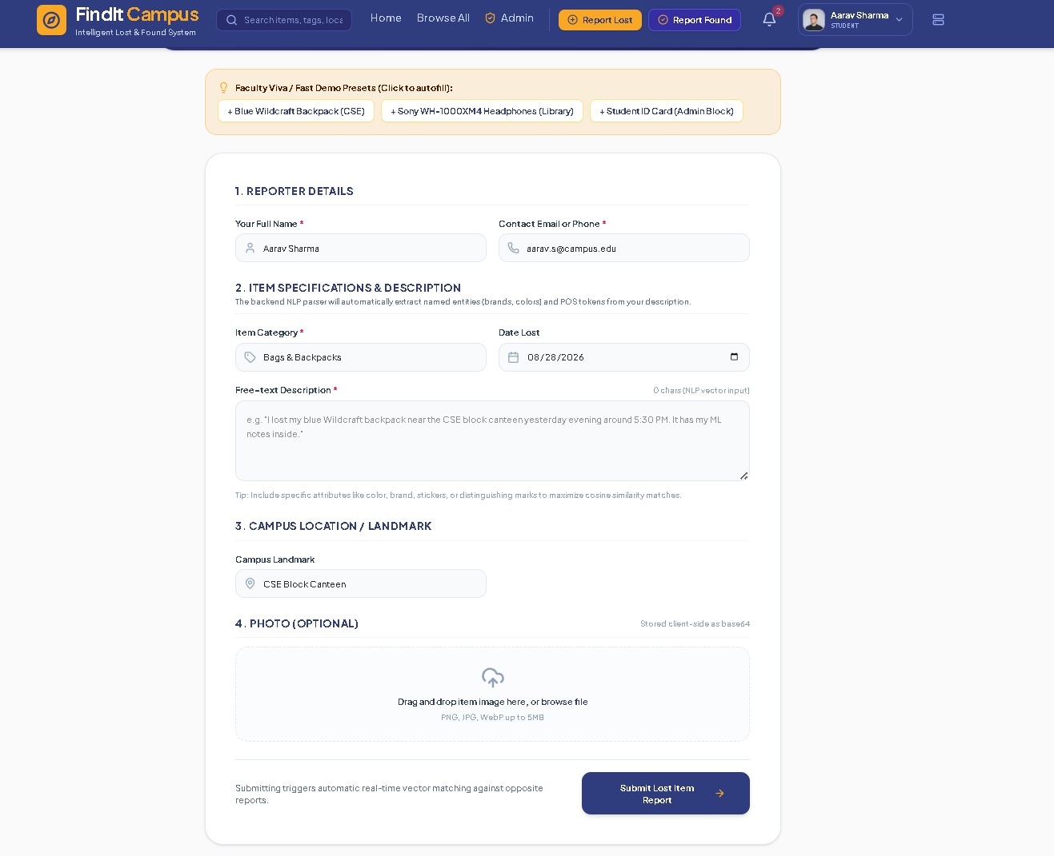
Figure A1: Report Lost form showing reporter details, item specification, campus landmark, and demo presets.

Figure A2 — Report Found Item Interface
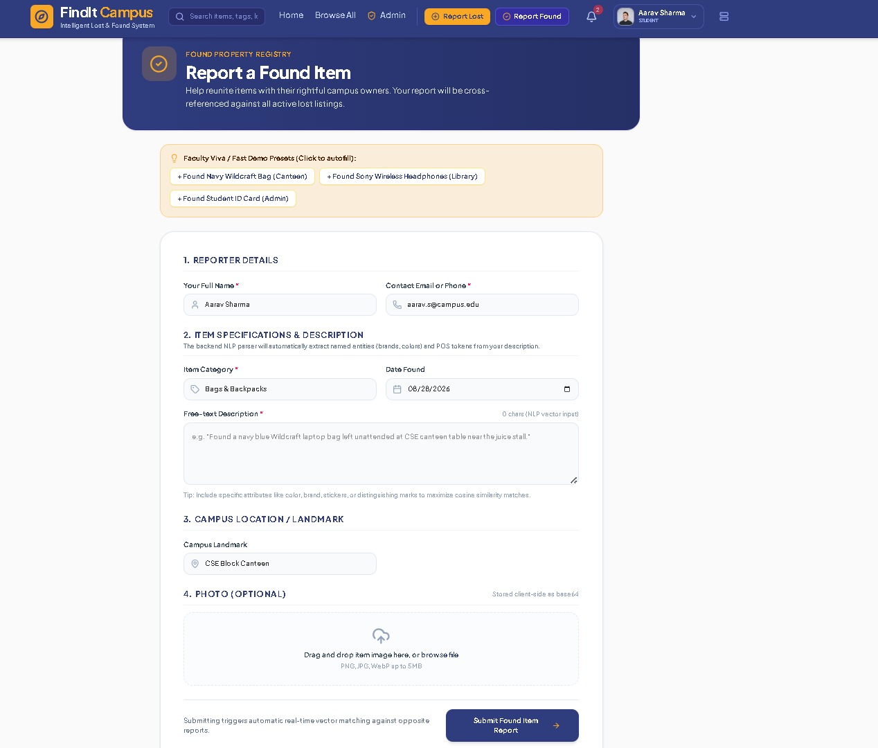
Figure A2: Report Found form, mirroring the lost-item workflow for recovered items.

Figure A3 — Browse Lost & Found Items Directory
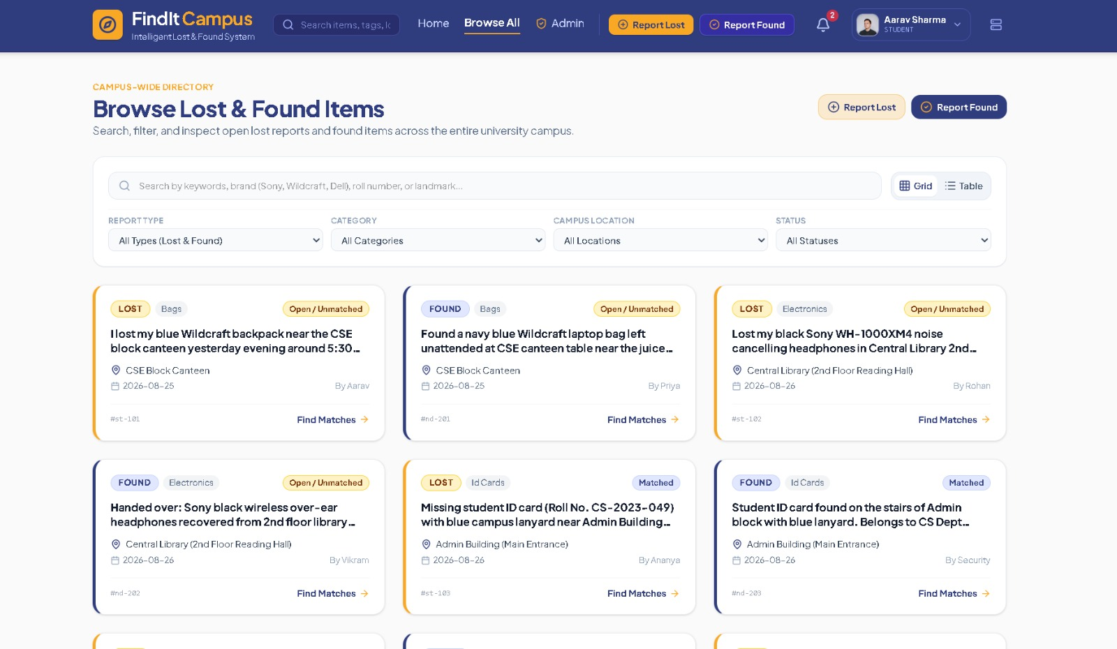
Figure A3: Campus-wide directory with search, category, location, and status filters.

Figure A4 — Administrator Dashboard
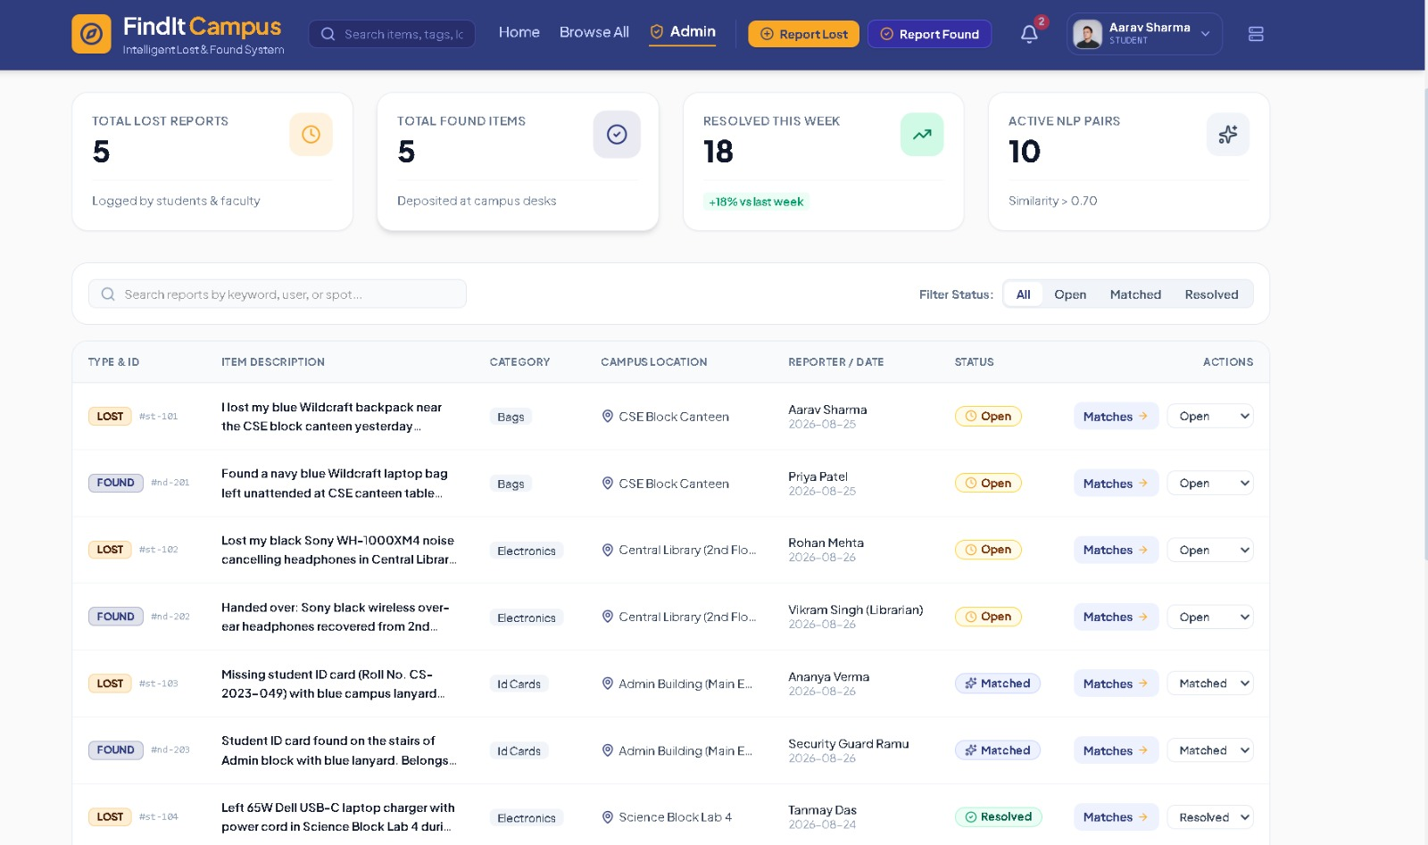
Figure A4: Admin console showing report volume, weekly resolution rate, and active NLP pairs.

